**Contributors: Ayush Pant, Thien Tran, Dominic Polcyn, Kaitlyn Younger**

Functionality:

* **1. Wearable Design**: The color-matching glove is designed to be worn comfortably on the user's hand. It is lightweight and ergonomic, allowing for ease of movement and flexibility.
* **2. Color Detection**: The glove is equipped with an RGB sensor capable of detecting the color of the clothing being scanned. When the user places their hand close to a piece of clothing, the sensor accurately identifies the color.
* **3. Proximity Sensing**: Utilizing an ultrasonic sensor, the glove can detect how close or far it is from the clothing. This feature ensures that the scanning process is initiated only when the glove is in close proximity to the fabric, conserving power and enhancing efficiency.
* **4. User Interaction**: A button located on the glove serves as the power control. Pressing the button activates the scanning process, while pressing it again stops the operation. This design allows for intuitive user interaction and control over the functionality of the glove.
* **5. Feedback Mechanisms**:
  + *Vibration Feedback:* As the user brings the glove closer to the clothing, a subtle vibration from the vibrator motor notifies them that the scanning process has commenced.
  + *Audio Feedback:* The glove is equipped with a speaker that provides auditory feedback to the user. It announces the detected color of the clothing in a clear and concise manner, enabling accessibility for visually impaired users.
* **6. Color Matching Suggestions**: Upon identifying the color of the clothing, the glove provides the user with suggestions for color-matching options. Using pre-programmed phrases, it recommends complementary colors and suitable combinations, aiding the user in creating well-coordinated outfits.
* **7. User-Friendly Interface**: The glove's interface is designed to be user-friendly and accessible. The auditory feedback is delivered in different phrases, ensuring variety and engagement for the user. Additionally, the glove maintains mobility and allows the user to feel the material of the clothing while scanning.
* Constraint Considerations:
  + *Budget and Time Limit:* The design of the glove takes into account budgetary constraints and time limitations, prioritizing cost-effective components and efficient development processes.
  + *Programming Ability:* The functionality of the glove does not rely on artificial intelligence, ensuring simplicity in programming and ease of implementation.
  + *Durability and Maintenance:* The glove is designed to be durable, with components selected for reliability and longevity. Maintenance requirements are minimal, contributing to the longevity of the product.
  + *Sensor Accuracy:* Accuracy of the sensors is a key consideration, with calibration and testing conducted to ensure precise color detection and proximity sensing.
  + *Weight Management:* The weight of the battery and components is optimized to maintain a lightweight design, enhancing comfort for the user during prolonged wear so

State diagram:

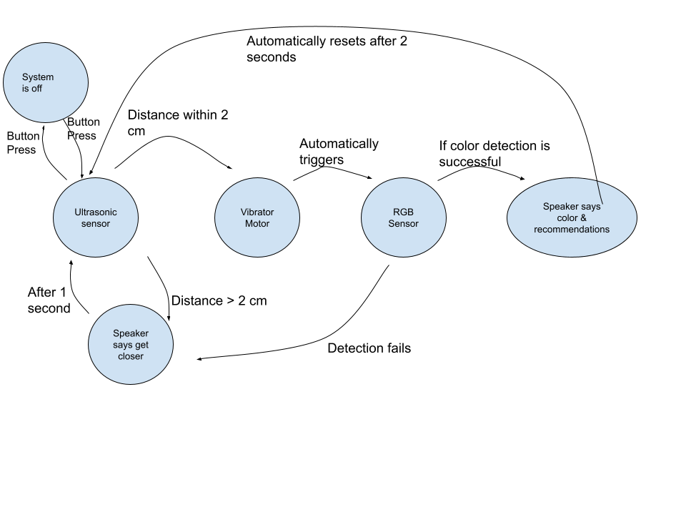

Ultrasonic Sensor:

* The ultrasonic sensor emits high-frequency sound waves and measures the time taken for the waves to bounce back after hitting an object. Based on the time delay, the sensor calculates the distance between the glove and the object.
* If the distance is within than 2 inches, it triggers the vibrator.
* If the distance is greater than 2 inches, it displays “get closer” and triggers the Speaker to say that text. Then, the process will be repeated after 1 second.

Vibrator Motor:

* The vibrator on the glove generates vibrations of varying intensity or patterns.
* Vibrations can be used to convey information to users.
* It is automatically triggered if the Ultrasonic sensor detects an object within 2 inches.

RGB Sensor:

* The RGB sensor detects colors of an object by measuring the intensity of Red, Green and Blue light reflected from the object. The sensor converts these intensity values into digital data representing the color spectrum.
* It is automatically triggered after the vibrator motor.
* It performs color detection and will display as text on the screen. Then the speaker is triggered to provide color information.

Button:

* A button is a physical input that the user can press to start the whole process of tracking object and detecting color of the glove
* After displaying the color information, the process automatically resets after 2 seconds.
* If you want to turn off the glove or change the objects, you can press the button to shut down the whole process.